**AN INTERNSHIP REPORT ON**

**Submitted by byby**

**drrfhagfarg**

**saj**

**A Report Submitted to**

**Blackbuck Engineers Pvt. Ltd**

* POKURU GREESHMANTH

ROLL NO.:20731A3542

BBID:BBPBV045

* PASUVULA AKASH

ROLL NO.:20731A3538

BBID:BBPBV044

* KORISAPTI VISHNU VARDHAN REDDY

ROLL NO.:20731A3520

BBID:BBPBV040

* GADDAM RAMANA REDDY

ROLL NO.:20731A3515

BBID:BBPBV038

# Blackbuck Engineers Pvt. Ltd

# Road no 36, Jubilee Hills,Hyderabad

## ACKNOWLEDGEMENT

We would like to acknowledge all those without whom this project would not have been successfull. Firstly, we would like to thank our C & Data Structures Programmer Mr.Gnanendra who guided us throughout the project and gave his immense support. He made us understand how to complete this project and without his presence, this project wouldn’t have been complete. We also got to know a lot about parallelization and its benefits. This project has been a source to learn and bring our theoretical knowledge to the real-life world. Once again, thanks to Blackbucks team for making this project successful.

Place : Kavali

Date : 02/09/2023

# ABSTRACT

1. **Objective:**

The main aim of this Movie World is online booking tickets for various movies in Registered theatres by the users.

1. **Problem Definition:**

Here details about Now playing movies and no of tickets available in a particular theatre for particular movie, Movie Details, ticket cost for registered users

1. **Existing System:**

Present System developed in asp .In asp there are some limitations.

* It is scripting language
* It is very code complexity
* There is server controls in asp
* It Doesn’t Support language interoperabilty

.

1. **Proposed System:**

Asp.net Support code behind technology

It supports different controls like html controls, server controls

It Supports language interoperability

This project contains three modules

**1 .Admin**

**2. Booking tickets**

**3. Users**

**1 Admin:** In this module administrator has to register the theatres assign movies to theatres, register users,

**2. Booking tickets**: In this details about booked tickets and tickets booking

Admin can update and delete purchase, sales and other details.

**3. Users:** In this users can see the showing movies and upcoming movies details , ticket booking and Registering as members.

**INDEX**

# CONTENTS

### Introduction 6-8

### Analysis 9-2

### Software requirements specifications 13

### Technologies 14-15

### C LANGUAGE

### Coding 16-22

### Screenshots 23-25

### Conclusion 27

### Bibliography 29

**CHAPTER – 1 INRODUCTION**

# INTRODUCTION

**● Movie Ticket Booking**

**System :**

Simple Movie Ticket Booking System is based on a concept of recording and booking customer’s movie ticket details. Here the user can perform all the tasks like booking a movie show, receiving tickets, and card registration and view all movie show details.There’s no loginsystem for this project. This project contains fewerfeatures but the essentials ones.



Talking about the features of the SimpleMovie Ticket Booking System, a user can select anymovie provided in the list. After selecting a show,he/she has to select timings, then the system asks for personal information which include Name, contactnumber. There are two type of seat clasess i.e. Normal class and Gold Class. For certain purpose, he/she can also make payment using the card. He/she has to provide card number, expiry date, and CVV. After that, the system automatically displays the final outcome which is the user’s bill. For the system, the user can

also register DT Card from the system.

This project uses classes and file handling features of C++. In order to store all the user’s data, an external file (DAT file) is created by the system, so every time we get into the system we can operate with the existing records. Simple Movie ticket booking System is

developed using C++ Programming Language and different variables, strings have been usedfor the development of it. Simple Movie Ticket Booking System in C++ Programming withsource code is free to download. Use for educational purposes only! This project provides thesimplest system for managing movie booking system.

**● Analysis of the project :**

Today, it is believed that the application of computer technology in any activity would go along way in making that activity much easier.

To the researcher, this statement remains a theory until proven otherwise by the implementation of online movie ticket reservation system.

It also believed that the benefit and advantages of using computer out weight that of the manual methods beyond doubt by the researcher through the implementation of the new system.

The main aim of this study is to design and implement an online movies ticket reservation system. This system will achieve the following objectives.

1. To establish an efficient way to promote the film on the internet.
2. To minimize the number of staff at the ticket box.
3. To increase the profit and obtain statistical information from the booking record.
4. To provide an anytime, anywhere service for the customers to book their movie ticket.
5. To create a reliable database of movies in the case study with their description.
6. For research purpose (project writing and defuse.

This research project will be unnecessary if it does not have significance to humanity.

The newly designed system is faster, more convenient and you do not have to

go to station twice.

Online ticket reservation is always a safe option, unless the website is insecure.

Booking online ticket is safe if the company you plan to use, uses a

Secure ServerSoftware (SSS).This basically hides year private information from there.

It saves a lot of money in printing cost because the company do not need to

printout ticketto give to customers which get binned after the film anyway.

it also saves a lot of time for the customers because, they do not need to arrived

early toqueue for ticket in case they are all sold out.

**Definition of Terms :**

In order to do away with ambiguity, some terms and keywords in the context of

this research are here by defined.

**Implementation :**

 Is the building of system and installation to ensure that it solve a particular task.

**System :**

 Is a combination of related parts into a complex whole.

**Database :**

 It is a collection of interrelated data stored together with controlled redundantly to serve one or more application in an optional fashion.

**Reservation :**

 Is the act of reserving something e.g hotel accommodation, a seat on an aeroplane, in a theatre.

**Ticket :**

 Is a piece of paper, cardboard, etc, showing that the holder is entitled to certain rights, such as travel on a train or bus, entry to a place of public.

**CHAPTER – 2 SYSTEM ANALYSIS**

# SYSTEM ANALYSIS

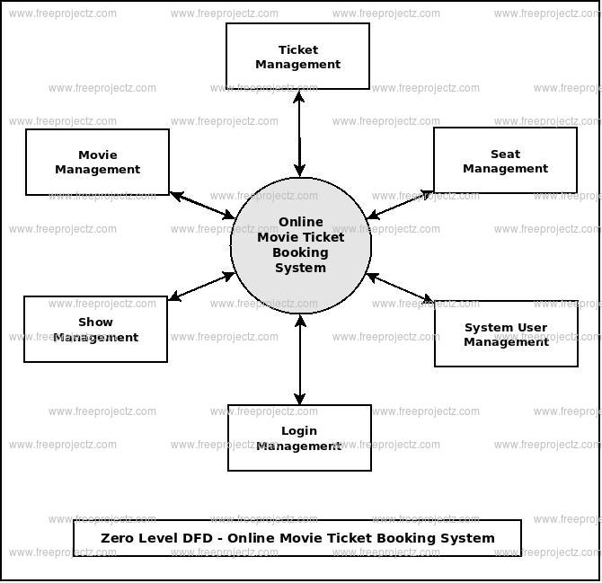

FLOW CHART OF THE PROGRAM

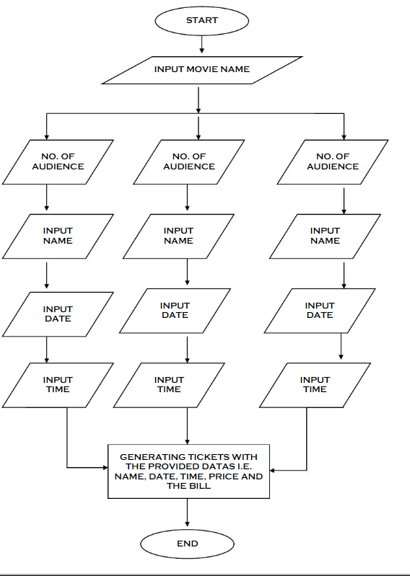



**CHAPTER – 3 SOFTWARE**

# SOFTWARE REQUIREMENTS SPECIFICATIONS

System configurations The software requirement specification can produce at the culmination of the analysis task. The function and performance allocated to software as part of system engineering are refined by established a complete information description, a detailed functional description, a representation of system behavior, and indication of performance and design constrain, appropriate validate criteria, and other information pertinent to requirements.

Software Requirements:

* Operating system : Windows 7 Ultimate.
* Coding Language : C

Hardware Requirement:

* System : Pentium IV 2.4 GHz.
* Hard Disk : 1TB.
* Ram : 16GB.

**CHAPTER-4**

**TECHNOLOGIES**

# CHAPTER-4 TECHNOLOGIES

### TECHNOLOGIES

**Introduction to C programming Language :**

C is a general-purpose programming language that is extremely popular, simple and flexible. Itis machine-independent, structured programming language which is used extensively invarious applications.

C was the basics language to write everything from operating systems (Windows and manyothers) to complex programs like the Oracle database, Git, Python interpreter and more.It is said that 'C' is a god's programming language.

One can say, C is a base for the programming. If you know 'C,' you can easily grasp the knowledge of the other programming languages that uses the concept of 'C'It is essential to have a background in computer memory mechanisms because it is animportant aspect when dealing with the C programming language.

**History of C programming Language :**

The base or father of programming languages is 'ALGOL.' It was first introduced in1960. 'ALGOL' was used on a large basis in European countries. 'ALGOL' introduced theconcept of structured programming to the developer community. In 1967, a new computer programming language was announced called as 'BCPL' which stands for Basic CombinedProgramming Language. BCPL was designed and developed by Martin Richards, especiallyfor writing system software. This was the era of programming languages. Just after three years,in 1970 a new programming language called 'B' was introduced by Ken Thompson thatcontained multiple features of 'BCPL.' This programming language was created using UNIXoperating system at AT&T and Bell Laboratories. Both the 'BCPL' and 'B' were system programming languages.In 1972, a great computer scientist Dennis Ritchie created a new programming language called'C' at the Bell Laboratories. It was created from 'ALGOL', 'BCPL' and 'B' programminglanguages.

'C' programming language contains all the features of these languages and manymore additional concepts that make it unique from other languages.'C' is a powerful programming language which is strongly associated with the UNIX operatingsystem. Even most of the UNIX operating system is coded in 'C'. Initially 'C' programmingwas limited to the UNIX operating system, but as it started spreading around the world, it became commercial, and many compilers were released for cross-platform systems. Today 'C'runs under a variety of operating systems and hardware platforms. As it started evolving manydifferent versions of the language were released. At times it became difficult for the developersto keep up with the latest version as the systems were running under the older versions. Toassure that 'C' language will remain standard, American National Standards Institute (ANSI)defined a commercial standard for 'C' language in 1989. Later, it was approved by theInternational Standards Organization (ISO) in 1990. 'C' programming language is also called as'ANSI C'.

**CHAPTER-5**

**CODING**

**CHAPTER-5 CODING**

### CODING

We need to write the code for HEADER and we have to import the library in our code and

load the data and import the libraries..

**SOURCE CODE:**

#include<stdio.h>

Int main ()

{

int n, t, i, temp;

float rs;

char name[12], movie;

char id, date;

printf ("~~~~~~~~~~WELCOME IN OUR OFFICIAL PAGE~~~~~~~~\n\n\n");

printf ("Printing the name of the movies:\n");

printf ("1.Housefull 4\n2.Made In China\n3.Jumanji\n4.Avengers Endgame\n\n\n"

);

printf ("Choose the movie:\n");

scanf ("%d",&id);

temp = id;

if (id == 1)

{

printf ("Entering into the Housefull 4...........\n");

}

else if (id == 2)

{

printf ("Entering into the Made In China...........\n");

}

else if (id == 3)

{

printf ("Entering into the Jumanji...........\n");

}

else if (id == 4)

{

printf ("Entering into the Avengers Endgame...........\n");

}

else

{

printf ("Database error.....\n Please Enter write Digits");

return 0;

}

printf ("You Entering into the Movie Ticket Booking Section\n\n\n");

printf ("The amount of movie is 250 Rs.per audience\n");

printf ("Number of Audience\n");

scanf ("%d", &n);

// n = n - 1;

if (n == 1)

{

printf ("Enter the name of the Audience\n");

scanf ("%s", &name[n]);

}

else

{

printf ("Enter the names of the Audiences\n");

for (i = 0; i <n; i++)

{

scanf ("%s", &name[n]);

}

}

printf ("In which date you want to see the movie_:10:2023\n");

scanf ("%d", &date);

printf ("Choose the time\n 1.10:30\n 2.1:30\n 3.3:30\n 4.7:00\n\n\n");

scanf ("%d",&t);

if (t == 1)

{

printf ("Your time is:10:30\n");

}

else if (t == 2)

{

printf ("Your time is:1:30\n");

}

else if (t == 3)

{

printf ("Your time is:3:30\n");

}

else

{

printf ("Your time is:7:00\n");

}

printf ("Printing all the details of the tickits....\n");

puts (name);

if (temp == 1)

{

printf ("Movie name : Housefull 4\n");

}

else if (temp == 2)

{

printf ("Movie name : Made In China\n");

}

else if (temp == 3)

{

printf ("Movie name : Jumanji\n");

}

else if (temp == 4)

{

printf ("Movie name : Avengers Endgame\n");

}

else

{

printf ("Database problem\n");

}

printf ("Date:%d:10:2023\n", date);

rs = n * 250 ;

printf ("Amount of Rs:%f\n", rs);

if (t == 1)

{

printf ("Time is:10:30 AM\n");

}

else if (t == 2)

{

printf ("Time is:1:30 PM\n");

}

else if (t == 3)

{

printf ("Time is:3:30 PM\n");

}

else

{

printf ("Time is:7:00 PM\n\n\n");

}

printf ("~~~~~~~~~~Thanking you for entering into theserver~~~~~~~\n");

return 0;

}

**CHAPTER-6**

**SCREENSHOTS**

## CHAPTER-6 SCREEN SHOTS

### SCREENSHOTS

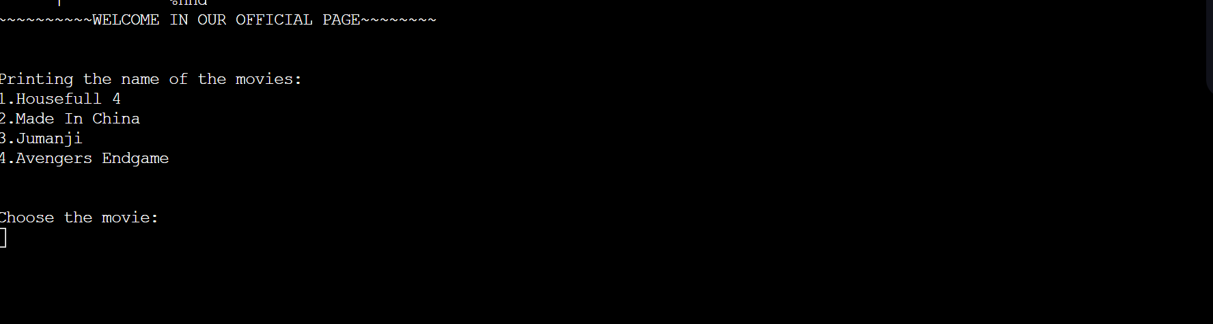

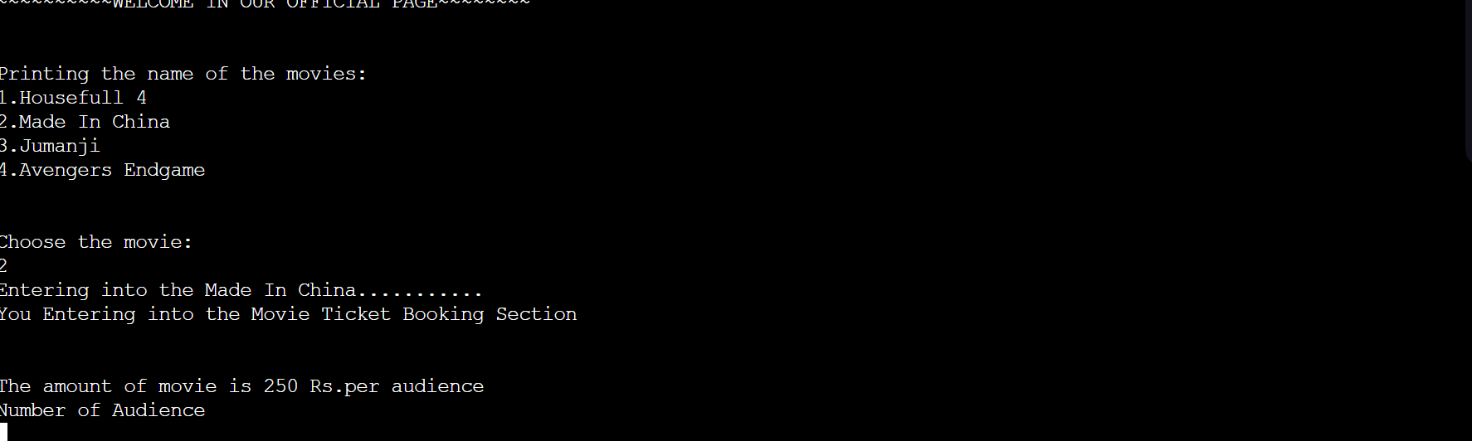

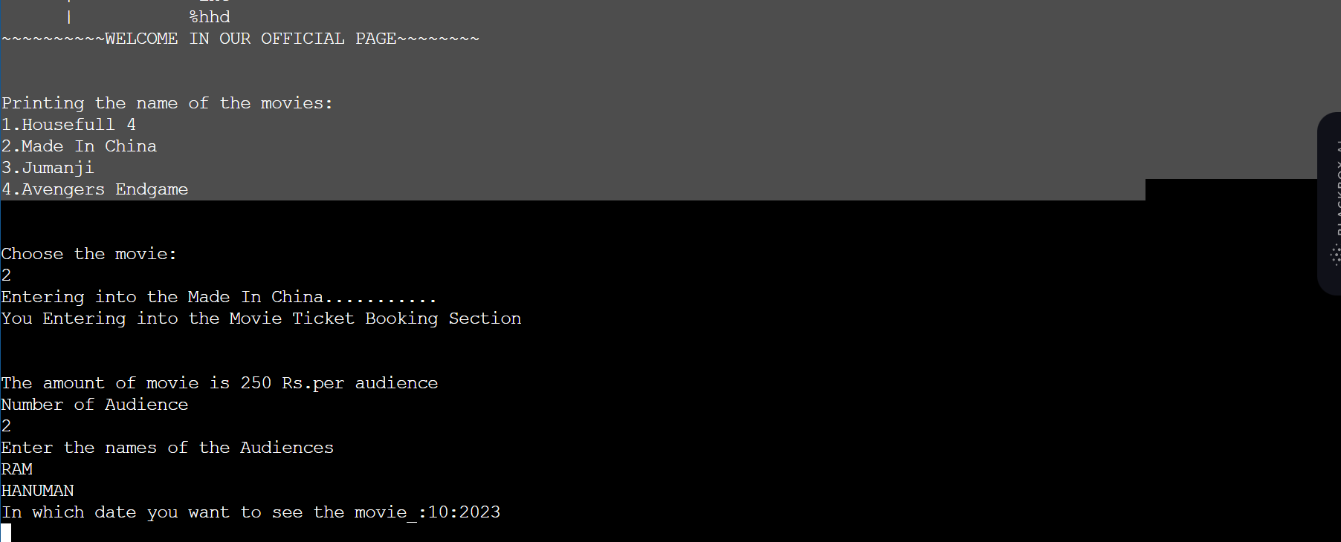

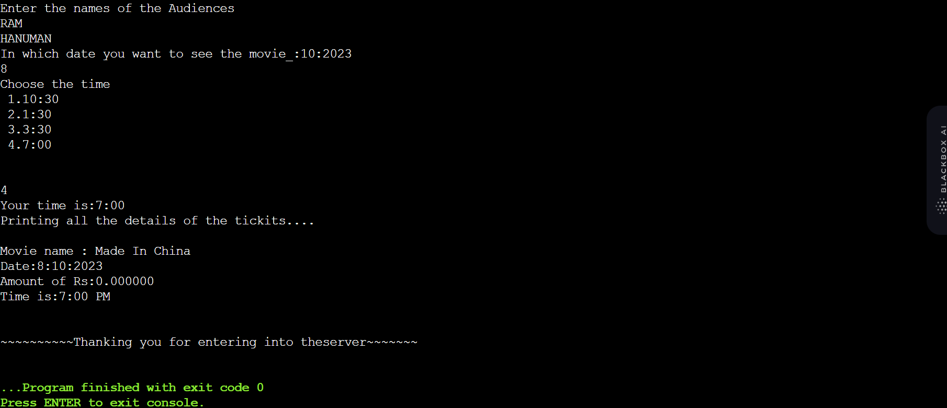

**CHAPTER-7**

**CONCLUSION**

## CHAPTER -7 CONCLUSION

### CONCLUSION

The entire project has been developed and deployed as per the requirements stated by the user, it is found to be bug free as per the testing standards that is implemented. Any specification-untraced errors will be concentrated in the coming versions, which are planned to be developed in near future. The system at present does not take care off the money payment methods, as the consolidated constructs need SSL standards and are critically to be initiated in the first face, the application of the credit card transactions is applied as a developmental phase in the coming days. The system needs more elaborative technicality for

its inception and evolution.

**CHAPTER-8**

**BIBILOGRAPHY**

## CHAPTER-8 BIBILOGRAPHY

### BIBLOGRAPHY

**1.ASP.NET (BIBLE)**

**-MRUDULA PARIHAR.**

**2. Mastering SQL Server 2000 by**

**-Gunderloy,Jorden BPB Publications**

**3. Beginning SQL Server 2000 by**

**-Thereon Willis wrox publications**

**.**

**4.SOFTWARE ENGINEERING (THEORETICAL APPROACH)**

**-ROGER S.PRESSMEN, T. Mc. GH.**

**5.C#.NET**

**-PROFESSIONAL VISUAL BASIC.NET**

**-WROX PUBLICATIONS.**

**6. MSDN LIBRARY.NET**

**-WWW.MICROSOFT.COM**